Finding from working on the site:

**Working with Stored Procedure:** We can call the stored procedure by declaring a @Procedure annotation on a method. The parameters we can pass as the method parameters.

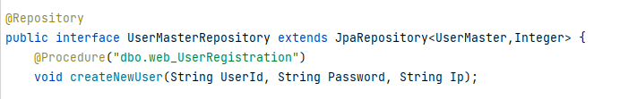

**Working with Native SQL Query:** This one been tricky so far, running the query isn’t problem. Assigning it to a object is a bit messy for now. It is not an issue for the entity class that mapped to a table. But when I want to get a native query result it is not working, getting error converting data type to entity type.